**Neural Network**

**Example-Concrete Dataset**

data.frame': 1030 obs. of 9 variables:

$ cement : num 141 169 250 266 155 ...

$ slag : num 212 42.2 0 114 183.4 ...

$ ash : num 0 124.3 95.7 0 0 ...

$ water : num 204 158 187 228 193 ...

$ superplastic: num 0 10.8 5.5 0 9.1 0 0 6.4 0 9 ...

$ coarseagg : num 972 1081 957 932 1047 ...

$ fineagg : num 748 796 861 670 697 ...

$ age : int 28 14 28 28 28 90 7 56 28 28 ...

$ strength : num 29.9 23.5 29.2 45.9 18.3 ...

**All variables are numeric and out target variable is Strength.**

**Box Plot 🡺**

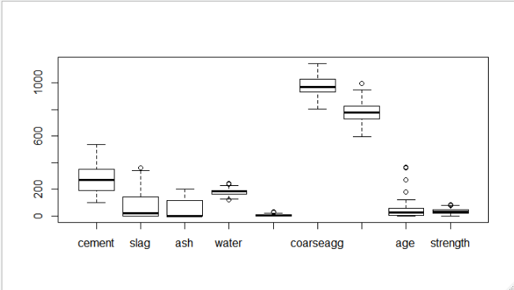

**From the above box plot, few variables are containing outliers so we will remove these outliers.**

**After removing outliers, we are getting another set of outliers.**

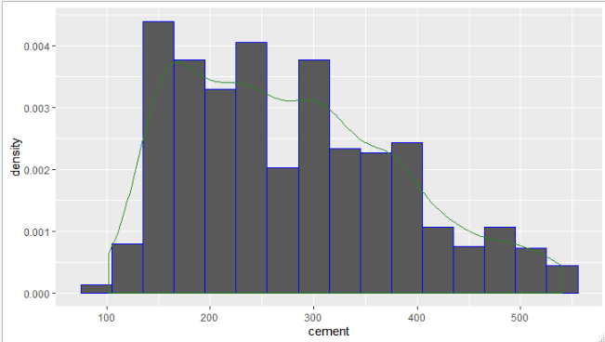

**From above histogram, we can say that it is positively skewed.**

**Model-1 🡺 Without hidden layers**

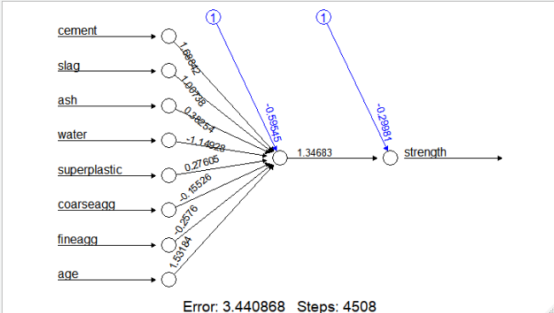

**Correlation 🡺 0.860514**

**RMSE 🡺8.7317**

**Model-2 🡺 With hidden layers = 5**

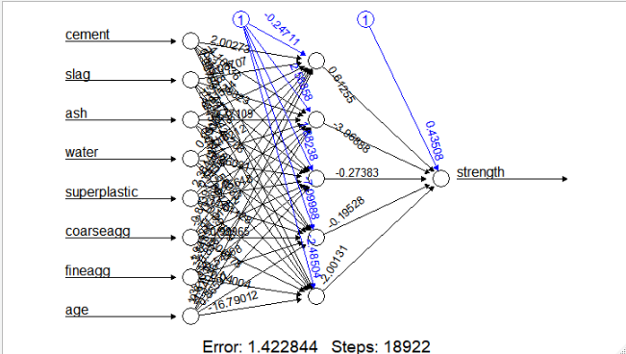

**Correlation 🡺 0.943952**

**RMSE 🡺5.649183**

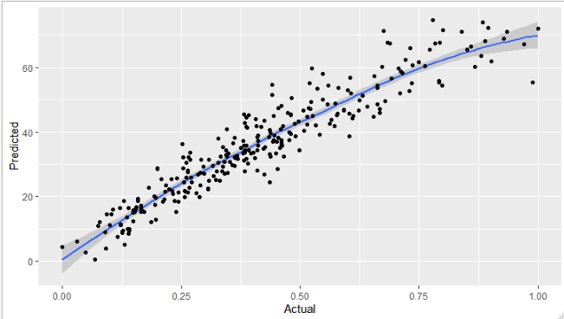

**From above information of accuracy and RMSE we are choosing Model-2 as our final model.**